# Dexamethasone as a Model of Stress

There are two types of stress, acute and chronic. Acute stress, in response to an immediate threat, is processed through the sympathetic nervous system to trigger a fight-or-flight response [1]. The acute stressor triggers the hypothalamic-pituitary-adrenal axis which releases cortisol/corticosterone in the cascade shown in *Figure 1*. If acute stress persists, this leads to chronic stress whereby cortisol/corticosterone levels remain elevated 1 (Stephens & Wand, 2012).

Although the majority of research has focused on glucocorticoid exposure during midgestation, long after placental development is complete, the majority of research has failed to address lifestyle stressors that pregnant women may encounter like low socioeconomic status, institutional racism, shootings, and other traumatizing events. Institutional racism and the events of 9/11 in New York City caused reductions in birthweight (Collins *et al.*, 2004; Eskenazi *et al.*, 2007). As these prolonged stressful events are not yet explored in animal models, the mechanisms of action by which stress influences placental development are not understood. Furthermore, glucocorticoid exposure during lactation is scarcely studied.

Dexamethasone is used in our models since it is a potent synthetic glucocorticoid that replaces endogenous cortisol/corticosterone levels. When given at our dose of 1mg/kg/day, dexamethasone causes a state of elevated glucocorticoids and mimics a state of stress (De Souza *et al.*, 1973). My aim is to determine the exact mechanisms by which dexamethasone, a potent synthetic cortisol substrate used to mimic chronic stress, affects placentation prior to the full development of the placenta and their effect on mammary gland function. Based on our results that will examine the mechanisms, our data can further be used to better understand the effect of stressors during different timepoints in early life.

## Figure 1: the HPA axis from “Know your brain: HPA axis”, 2014 [2]

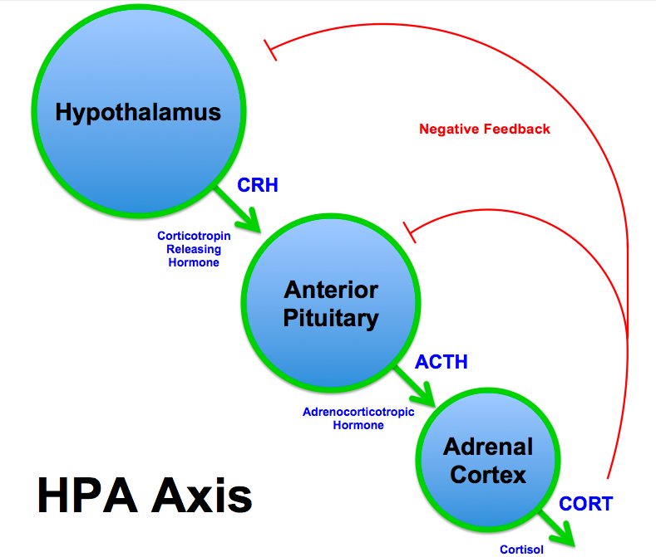

# mTORC1 Hyperactivation as a Model of Obesity

## Placental mTORC1

Mechanistic target of rapamycin 1 (mTORC1) is a crucial nutrient sensor that plays a role in integrating maternal and fetal signals to ensure adequate nutrient transport to the fetus through the placenta (Wen *et al.*, 2005; Roos *et al.*, 2007; Mparmpakas *et al.*, 2012; Jansson & Powell, 2013). mTORC1 has been identified as being upregulated in obesity and was implicated as the main driver of offspring phenotype in maternal obesity (Jansson *et al.*, 2013). My model of mTORC1 hyperactivation in the placenta, allows us to better test the mechanisms by which placental mTORC1 affects placental function and offspring outcome. Furthermore, this model further elucidates exact mechanisms of mTORC1 without the confounding variables stemming from maternal obesity such as altered insulin sensitivity, glucose homeostasis, adipokine and hormone levels, and inflammatory profile. Strengths: better understand the role of mTORC1 as it has been implicated as the main driver of fetal growth in obesity.

## Adipocyte mTORC1

mTORC1 is a nutrient sensor and a main regulator of protein and lipid synthesis (Wang & Proud, 2006; Cai *et al.*, 2016). Obesity, identified by having excess fat mass, promotes mTORC1 activity (Catania *et al.*, 2011). In obese subjects, gene expression of mTORC1 was upregulated in the visceral fat compartments (Catalán *et al.*, 2015). My model of adipocyte mTORC1 hyperactivation mimics the obesogenic environment and better allows us to understand the mechanisms by which milk composition and volume are altered in a nutrient-excess medium with mTORC1 hyperactivation. It is worth noting that our model has mTORC1 hyperactivation in all the adipocytes and not specifically the mammary adipocytes, as no mammary-gland-specific adipocyte driver has been identified yet.

# Strengths and Limitations of Using Mouse Model

## Mice vs Humans

Human and mice are both mammals that develop very similarly [3]. The mouse and human genome is also 85% similar [4] and both mammals share very similar organ and system functions (Rangarajan & Weinberg, 2003). Genome editing is possible in a mouse model but not in humans, allowing us to better understand mechanisms. Furthermore, tissue collection in mice is feasible at any point in life. The proposed experiments in my proposal would be unethical to conduct in human data. Additionally, human samples (i.e. placentas) cannot be easily collected anytime during pregnancy due to ethical considerations. Even with human samples available, it is very hard to discern the exact mechanisms at play since humans are complex beings that are influenced by multiple exposures and lifestyle. Mice, on the other hand, are easier to control, manipulate, and assess environmental or dietary exposures for, which makes our analysis less confounded by multiple variables. Despite their great use, mice are not a perfect model to replicate human development, but they remain an invaluable resource to elucidate potential mechanisms at play.

## Mice vs Cells

Studying cells in media has advanced science whether it is using human/animal cell lines or tissue explants. Cell studies are cheaper, easier to purchase, and easier to manipulate by changing the media constituents [5]. Nonetheless, cell studies remain very limited and far removed from the effects of the bodily systems, making extrapolating data to humans very challenging since they are studied outside their natural environment, inside the body, where they are in contact with other cell types and systems (Kaur & Dufour, 2012). Mouse models still offer a better option as opposed to cell studies as the mouse allows for broader understanding of organ functionality and role when the full body is otherwise intact and functioning.

Cai H, Dong LQ & Liu F (2016). Recent Advances in Adipose mTOR Signaling and Function: Therapeutic Prospects. *Trends Pharmacol Sci* **37,** 303–317.

Catalán V, Gómez-Ambrosi J, Rodríguez A, Ramírez B, Andrada P, Rotellar F, Valentí V, Moncada R, Martí P, Silva C, Salvador J & Frühbeck G (2015). Expression of S6K1 in human visceral adipose tissue is upregulated in obesity and related to insulin resistance and inflammation. *Acta Diabetol* **52,** 257–266.

Catania C, Binder E & Cota D (2011). mTORC1 signaling in energy balance and metabolic disease. *Int J Obes* **35,** 751–761.

Collins JW, David RJ, Handler A, Wall S, Andes S & Andes S (2004). Very low birthweight in African American infants: the role of maternal exposure to interpersonal racial discrimination. *Am J Public Health* **94,** 2132–2138.

Eskenazi B, Marks AR, Catalano R, Bruckner T & Toniolo PG (2007). Low birthweight in New York city and upstate New York following the events of September 11th. *Hum Reprod* **22,** 3013–3020.

Jansson N, Rosario FJ, Gaccioli F, Lager S, Jones HN, Roos S, Jansson T & Powell TL (2013). Activation of Placental mTOR Signaling and Amino Acid Transporters in Obese Women Giving Birth to Large Babies. *J Clin Endocrinol Metab* **98,** 105–113.

Jansson T & Powell TL (2013). Role of placental nutrient sensing in developmental programming. *Clin Obstet Gynecol* **56,** 591–601.

Kaur G & Dufour JM (2012). Cell lines: Valuable tools or useless artifacts. *Spermatogenesis* **2,** 1–5.

Mparmpakas D, Zachariades E, Goumenou A, Gidron Y & Karteris E (2012). Placental DEPTOR as a stress sensor during pregnancy. *Clin Sci (Lond)* **122,** 349–359.

Rangarajan A & Weinberg RA (2003). Comparative biology of mouse versus human cells: modelling human cancer in mice. *Nat Rev Cancer* **3,** 952–959.

Roos S, Jansson N, Palmberg I, Säljö K, Powell TL & Jansson T (2007). Mammalian target of rapamycin in the human placenta regulates leucine transport and is down-regulated in restricted fetal growth. *J Physiol* **582,** 449–459.

De Souza SW, F Adlard BP & Souza D (1973). *Growth of suckling rats after treatment with dexamethasone or cortisol Implications for steroid therapy in human infants*. Available at: https://www.ncbi.nlm.nih.gov/pmc/articles/PMC1648459/pdf/archdisch00863-0029.pdf [Accessed August 18, 2019].

Stephens MAC & Wand G (2012). Stress and the HPA axis: role of glucocorticoids in alcohol dependence. *Alcohol Res* **34,** 468–483.

Wang X & Proud CG (2006). The mTOR Pathway in the Control of Protein Synthesis. *Physiology* **21,** 362–369.

Wen HY, Abbasi S, Kellems RE & Xia Y (2005). mTOR: A placental growth signaling sensor. *Placenta* **26,** S63–S69.

1. Understanding the stress response, Harvard Health Publishing, HARVARD MEDICAL SCHOOL. Retrieved from <https://www.health.harvard.edu/staying-healthy/understanding-the-stress-response>
2. Know your brain: HPA axis, NEUROSCIENTIFICALLY CHALLENGED,Published June 04,2014. Retrieved from: <https://www.neuroscientificallychallenged.com/blog/2014/5/31/what-is-the-hpa-axis>
3. Why are mice considered excellent models for humans?, The Jackson Laboratory. Retrieved from <https://www.jax.org/why-the-mouse/excellent-models>
4. The Mouse Model: Less than Perfect, Still Invaluable, Institute for Basic Biomedical Sciences, JOHNS HOPKINS MEDICINE. Retrieved from <https://www.hopkinsmedicine.org/institute_basic_biomedical_sciences/news_events/articles_and_stories/model_organisms/201010_mouse_model.html>
5. Mouse Cell Line, ingenious targeting laboratory. Published January 2, 2018. Retrieved from <https://www.genetargeting.com/stem-cell/mouse-cell-line/>